

Summer 2020

Web development bootcamp

Session 1

24 june

**Position relative vs absolute in CSS:**

position: relative;

An element with position: relative; is positioned relative to its normal position.

Setting the top, right, bottom, and left properties of a relatively-positioned element will cause it to be adjusted away from its normal position. Other content will not be adjusted to fit into any gap left by the element.

position: absolute;

An element with position: absolute; is positioned relative to the nearest positioned ancestor (instead of positioned relative to the viewport, like fixed).

However; if an absolute positioned element has no positioned ancestors, it uses the document body, and moves along with page scrolling.

Note: A "positioned" element is one whose position is anything except static.

Here is a simple example:

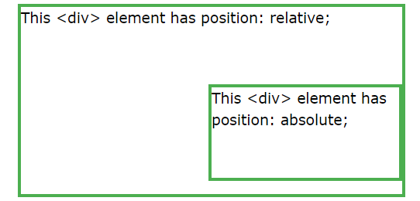

Overlapping Elements

When elements are positioned, they can overlap other elements.

The z-index property specifies the stack order of an element (which element should be placed in front of, or behind, the others).

An element can have a positive or negative stack order:

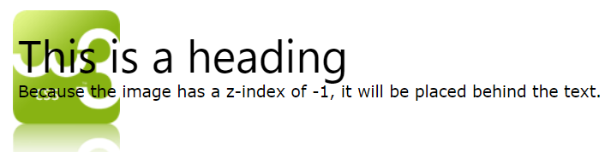

There 2 more positions: fixed (fix on the screen even while scrolling) and sticky

**CSS Box Sizing Property**

box-sizing Defines how the width and height of an element are calculated: should they include padding and borders, or not.

By default, the width and height of an element is calculated like this:

width + padding + border = actual width of an element

height + padding + border = actual height of an element

This means: When you set the width/height of an element, the element often appears bigger than you have set (because the element's border and padding are added to the element's specified width/height).

The following illustration shows two <div> elements with the same specified width and height:

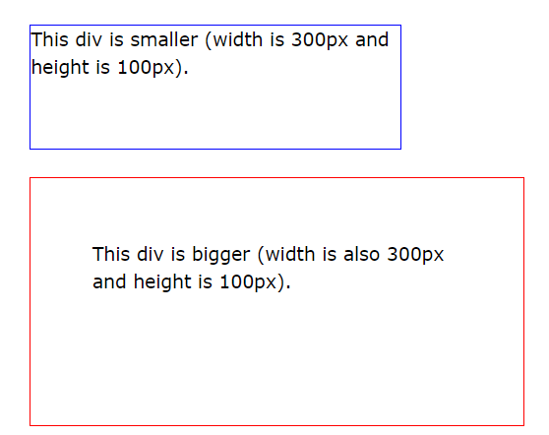

**The CSS Box Model**

All HTML elements can be considered as boxes. In CSS, the term "box model" is used when talking about design and layout.

The CSS box model is essentially a box that wraps around every HTML element. It consists of: margins, borders, padding, and the actual content. The image below illustrates the box model:

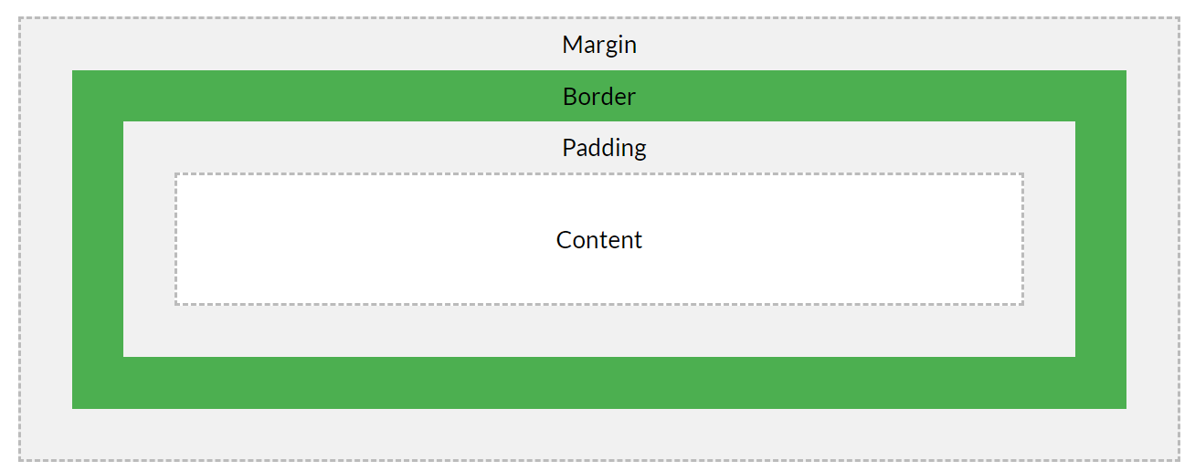

Explanation of the different parts:

* **Content** - The content of the box, where text and images appear
* **Padding** - Clears an area around the content. The padding is transparent
* **Border** - A border that goes around the padding and content
* **Margin** - Clears an area outside the border. The margin is transparent

Reference:

<https://www.w3schools.com/css/css3_box-sizing.asp>